- INTRODUCTION

Video games are very popular electronic devices,which was invented in 1980s.It is a most selling device in past years. Now it is turned to machines which of high cost.In my project i implementing a old ping pong game in a 8x8 led matrix.
The user can play this game with the joystick same as in conventional videogames. The circuit consist of 4 section, first section is the pong board with 8x8 led matrix and 2 8led strip for pad section. A decoding section to decode entire 8x8 led matrix. The controlling section is done by 2 controllers namely atmel Atmega8. The function of 1st microcontroller is that,it is dedicated to game purpuse only.The 2nd controller controlles entire funtion of gaming console. It controlls the game and it display the score,level and life.The 4th section is display section which is for displaying score, life and level.It is done through an LCD.

2.DEVELOPMENT AND HISTORY

2.1 History of Pong Game

Pong is a two-dimensional sports game which simulates table tennis. The player controls an in-game paddle by moving it vertically across the left side of the screen, and can compete against either a computer controlled opponent or another player controlling a second paddle on the opposing side. Players use the paddles to hit a ball back and forth. The aim is for a player to earn more points than the opponent; points are earned when one fails to return the ball to the other

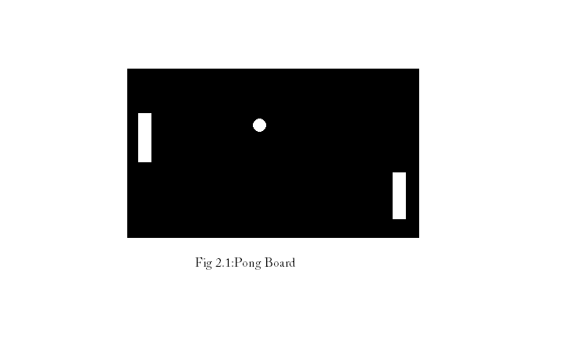

Pong was the first game developed by Atari Inc., founded in June 1972 by Nolan Bushnell and Ted Dabney. After producing Computer Space, Bushnell decided to form a company to produce more games by licensing ideas to other companies. Their first contract was with Bally Technologies for a driving game. Soon after the founding, Bushnell hired Allan Alcorn because of his experience with electrical engineering and computer science;

Atari, Alcorn had no experience with video games. To acclimate Alcorn to creating games, Bushnell and Dabney also had previously worked with him at Ampex. Prior to working at Bushnell gave him a project secretly meant to be a warm-up exercise. Bushnell told Alcorn that he had a contract with General Electric for a product, and asked Alcorn to create a simple game with one moving spot, two paddles, and digits for score keeping. The project was inspired by a game included in the first video game console, the Magnavox Odyssey—in May 1972, Bushnell had visited the Magnavox Profit Caravan in Burlingame, California where he played the Magnavox Odyssey demonstration, specifically the table tennis game.
Alcorn first examined Bushnell's schematics for Computer Space, but found them to be illegible. He went on to create his own designs based on his knowledge of transistor–transistor logic and Bushnell's game. Feeling the basic game was too boring, Alcorn added features to give the game more appeal. He divided the paddle into eight segments to change the ball's angle of return. For example, the center segments return the ball a 90° angle in relation to the paddle, while the outer segments return the ball at smaller angles. He also made the ball accelerate the more it was returned back and forth between paddles; missing the ball reset the speed. Another feature was that the in-game paddles could not reach the top of screen. This was caused by a simple circuit which had an inherent defect. Instead of dedicating time to fixing the defect, Alcorn decided it gave the game more difficulty and helped limit the time the game could be played; he imagined two skilled players being able to play forever otherwise.
Three months into development, Bushnell told Alcorn he wanted the game to feature realistic sound effects and a roaring crowd. Dabney also wanted the game to "boo" and "hiss" when a player lost a round. Alcorn was running out of room on the circuit board and did not know how to create such sounds with digital circuits. After inspecting the sync generator, he discovered it could generate different tones and used those for the game's sound effects. To construct the prototype, Alcorn purchased a black and white television set from a local store, placed it into a 4 feet (1.2 m) wooden cabinet, and soldered the wires into boards to create the necessary circuitry. The prototype impressed Bushnell

and Dabney so much that they felt it could be a profitable product and decided to test its marketability.
Atari had established a pinball route consisting of local businesses to generate steady income. In September 1972, Bushnell and Alcorn installed the Pong prototype at a local bar, Andy Capp's Tavern; they selected the bar because of their good working relation with the bar's manager, Bill Gaddis. They placed the prototype on one of the tables near the other entertainment machines: a jukebox, pinball machines, and Computer Space. The game was well received the first night and its popularity continued to grow over the next one and a half weeks. Bushnell then went on a business trip to Chicago to demonstrate Pong to executives at Bally and Midway Manufacturing; he intended to use Pong to fulfill his contract with Bally, rather than the driving game . A few days later, the prototype began exhibiting complications and Gattis contacted Alcorn to fix it. Upon inspecting the machine, Alcorn discovered the mechanisms had jammed from an overflow of quarters.
After hearing about the game's success, Bushnell decided there would be more profit for Atari to manufacture the game rather than license it, but the interest of Bally and Midway had already been piqued. Bushnell decided to inform each of the two groups that the other was not interested—Bushnell told the Bally executives that the Midway executives did not want it and vice versa—to preserve the relationships for future dealings. Upon hearing this, the two groups declined Bushnell's offer. Bushnell had difficulty finding financial backing for Pong; banks viewed it as a variant of pinball, which at the time the general public associated with the Mafia. Atari eventually obtained a line of credit from Wells Fargo that it used to expand their facilities to house an assembly line. Management sought assembly workers at the local unemployment office, but was unable to keep up with demand. The first arcade cabinets produced were assembled very slowly, about ten machines a day, many of which failed quality testing. Atari eventually streamlined the process and began producing the game in greater quantities. By 1973, they began shipping Pong to other countries with the aid of foreign partners.

Home version
The success of Pong resulted in Bushnell pushing his employees to create new products.In 1974, Atari engineer Harold Lee proposed a home version of Pong that would connect to a television: ome Pong. The system began development under the codename Darlene,named after an attractive female employee at Atari. Alcorn worked with Lee to develop the designs and prototype, and based them on the same digital technology used in their arcade games. The two worked in shifts to save time and money; Lee worked on the design's logic during the day,while Alcorn debugged the designs in the evenings. After the designs were approved, fellow Atari engineer Bob Brown assisted Alcorn and Lee in building a prototype. The prototype consisted of a device attached to a wooden pedestal containing over a hundred wires, which would eventually be replaced with a single chip designed by Alcorn and Lee; the chip had yet to be tested and built before the prototype was constructed. The chip was finished in the later half of 1974, and was, at the time, the highest performing chip used in a consumer product.

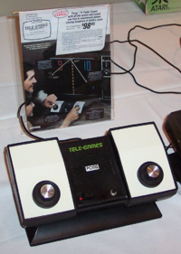

Atari's Home Pong console, released through Sears in 1975, and the original Sears Catalog advertisement.

3.DESCRIPTION AND WORKING

3.1 Block Diagram

PONG BOARD
8x8 LED MATRIX

DECODER SECTION

ATMEGA8 FOR GAME PURPUSE

JOY STICK

BUZZER UNIT

ATMEGA 8 FOR DISPLAY

LCD

Fig3.1:Basic Block Diagram

3.2 Block Diagram Explanation

3.2.1 Pong Board 8x8 Matrix: This section consist of an 8x8 led matrix and 2 rows of 8 leds.The purpuse of this section is to display the game.Each LED represents each pixel
3.2.2 Atmega8 For Game Purpuse: This section is used to controll the Pong Board.Atmega8 is microcontroller by a Atmel. The microcontroller contain the program to drive the LED matrix.The output of this section is fed to the decoder section.
3.2.3 Decoder Section: This section is used to decode the 8x8 matrix.An active high 3x8 decoder and active low 3x8 decoder decodes column and row of 8x8 matrix.The input of this section is from microcontroller section.
3.2.4 Atmega8 For Display: This section is to controll the display unit LCD.This section is connected to Game controller.The life,score and level is read by this unit and display in LCD.
3.2.5 LCD: This section is the display section of this console. LCD displays life,level and score of the game
3.2.6 JoyStick: This section is used to play the game.The 2 pad of this game is controlling by this joystick.It has 3 keys for moving left and right,and for reset
3.2.7 Buzzer Unit: This section is used for alert purpuse.Buzzer will make sound if life lost and also when the game fail.

3.3 Circuit Diagram

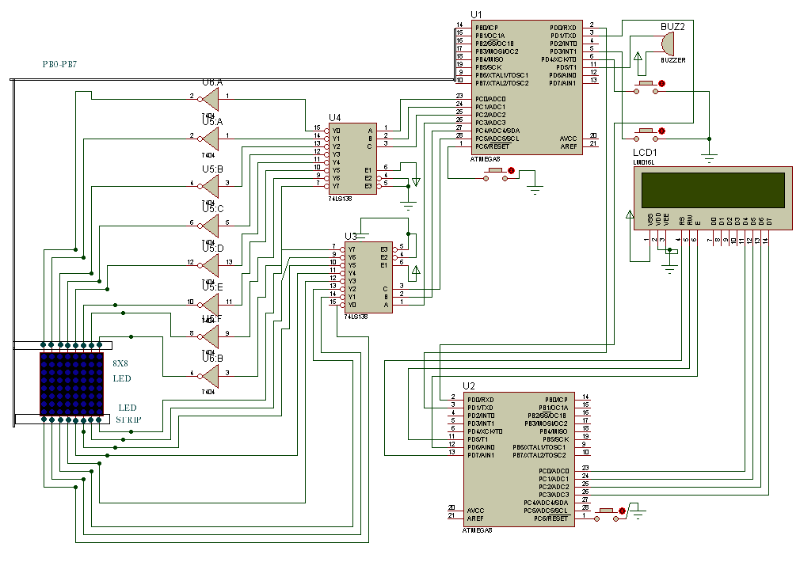

Fig 3.3:Circuit Diagram

3.4 Circuit Operation

Instead of proceeding with the circuit description,we start with the operation,as
This helps to understand the circuit better,The operation is as follows

- When the circuit is powered with 5v supply or battery ,the circuit energizes and it began to work.

- The LCD shows the discription about the console and loading procedure.

- After the loading sequence,the lcd microcontroller will send a starting signal to game controller to start.

- At starting, matrix shows a Pong face until the game starts.

- When the game starts 2 pads will appear i

PONG BOARD

8x8 LED MATRIX

ATMEGA8 FOR GAME PURPUSE

JOY STICK

BUZZER UNIT

ATMEGA 8 FOR DISPLAY

LCD

2.2 Block Diagram Description

The blocks of pong game is shown above.The main part of this game console is

already mentioned.The 2 microcontrollers are interconnected by serial

communication.The 2nd microcontroller send controll signal to 1st microcontroller

to start game and it recieves the score details from 1st mc for displaying them in

LCD.The joystick uses to controll the game.A buzzer unit is placed in 1st mc

To indicate whether ball touch the pad or not.

Design And Development
3.1 CIRCUIT DIAGRAM

3.2 CIRCUIT DESIGN WORKING

Basic circuit of pong gaming led matrix

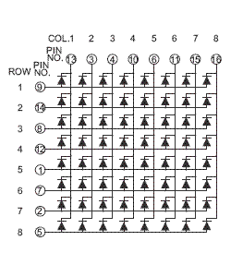
Led matrix is very interesting circuit,in which we can make a lot of type of

display.The led are connected in a specfied manner as shown in fig.There

are 8 row pin and 8 column pins.Each led can be acess by giving

appropraite output to row and column.Handling 8 rows and 8 columns is

very tough job.The challenge is that ,we cant acess each led easily.My logic

was to acess each led of 8x8 matrix with as easier as possible.For that I

placed an active high 3 to 8 decoder in row pins and placed active 3 to 8

decoder in column pins.So we easily acess each led by using 6 pins from

decoder.Then I make a decoder matrix,ie for each led in 8x8 matrix what is

the input value,I got the result that ,when we want to on a particular led,we

have to put the position of led.For eg if I want to on 8 th led,I will put 8 in

binary to decoder.So the processing will be easier.The diagram of decoder

circuit is show below

3 to 8 active low decoder

3 to 8

Active

High

decoder

Basic circuit of LCD

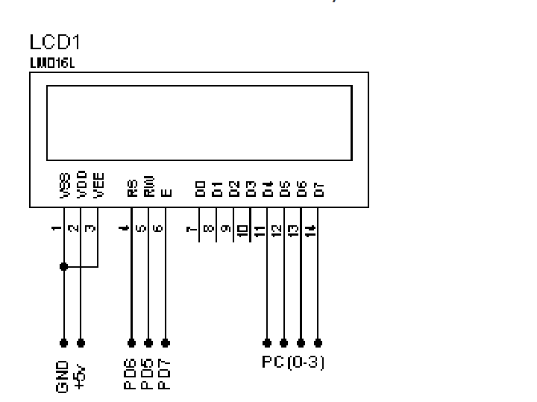

LCD is widely used for display purpuses.In this project LCD is interfaced with one of the atmel microcontroller.It will display score,level,and life of the gamer.It also show whether the player win or lose.LCD have vcc,gnd ,control lines and dataports
As shown in fig.
3.3 PROGRAM FLOW CHART(1st MC)

START

8X8 MATRIX PLOT TO 64 VALUES

MOVE BALLL IN RANDOM

IF KEY
PRESS
Y
CHANGE PAD POSITION

N

STOP

3.3 PROGRAM FLOW CHART(2nd MC)\

START

RECIVE VALUES FROM 1ST M

PRINT TO LCD

STOP

3.4 COMPONENET LIST

COMPONENT VALUE NUMBER

1. RESISTOR 1kohm 24

2.BLUE LED 64

3.WHITE LED 16

4.ATMEGA8 2

5.LCD 1

6.74LS138 2

7.74LS04 2

Result&Discussion

4.2 CONCLUSION

Pong game is video game,which is derived from tennis,it

very interesting game,when it employed on a led matrix ,it will be more

Attractive than,comapared to television.Its purely aim is

entertainment.electronic field has big hold on entertainment field.We

can utalize chances and make a big profit.

4.3 REFERENCE

- www.electronics4u.com
- www.datasheet4u.com
- www.wikipedia.com
- www.google.com
- www.extremeelectronics.co.in

